PANCAR WAHYU SETIABI

H1D024018

SHIFT D

1. Tampilkan semua table pada skema orderentry antara lain table

* Table customers
* Table orderitems
* Table orders
* Table products
* Table productnotes
* Table vendors

JAWAB

* Table customers

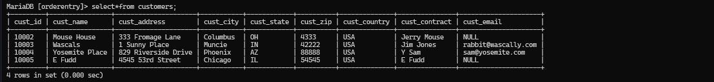

MariaDB [orderentry]> select*from customers;

+---------+----------------+---------------------+-----------+------------+----------+--------------+---------------+---------------------+

| cust_id | cust_name | cust_address | cust_city | cust_state | cust_zip | cust_country | cust_contract | cust_email |

+---------+----------------+---------------------+-----------+------------+----------+--------------+---------------+---------------------+

| 10002 | Mouse House | 333 Fromage Lane | Columbus | OH | 4333 | USA | Jerry Mouse | NULL |

| 10003 | Wascals | 1 Sunny Place | Muncie | IN | 42222 | USA | Jim Jones | rabbit@wascally.com |

| 10004 | Yosemite Place | 829 Riverside Drive | Phoenix | AZ | 88888 | USA | Y Sam | sam@yosemite.com |

| 10005 | E Fudd | 4545 53rd Street | Chicago | IL | 54545 | USA | E Fudd | NULL |

+---------+----------------+---------------------+-----------+------------+----------+--------------+---------------+---------------------+

4 rows in set (0.000 sec)

* Table orderitems

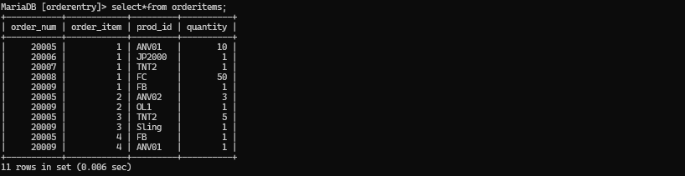

MariaDB [orderentry]> select*from orderitems;

+-----------+------------+---------+----------+

| order_num | order_item | prod_id | quantity |

+-----------+------------+---------+----------+

| 20005 | 1 | ANV01 | 10 |

| 20006 | 1 | JP2000 | 1 |

| 20007 | 1 | TNT2 | 1 |

| 20008 | 1 | FC | 50 |

| 20009 | 1 | FB | 1 |

| 20005 | 2 | ANV02 | 3 |

| 20009 | 2 | OL1 | 1 |

| 20005 | 3 | TNT2 | 5 |

| 20009 | 3 | Sling | 1 |

| 20005 | 4 | FB | 1 |

| 20009 | 4 | ANV01 | 1 |

+-----------+------------+---------+----------+

11 rows in set (0.006 sec)

* Table orders

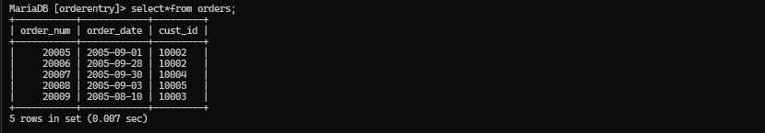

MariaDB [orderentry]> select*from orders;

+-----------+------------+---------+

| order_num | order_date | cust_id |

+-----------+------------+---------+

| 20005 | 2005-09-01 | 10002 |

| 20006 | 2005-09-28 | 10002 |

| 20007 | 2005-09-30 | 10004 |

| 20008 | 2005-09-03 | 10005 |

| 20009 | 2005-08-10 | 10003 |

+-----------+------------+---------+

5 rows in set (0.007 sec)

* Table products

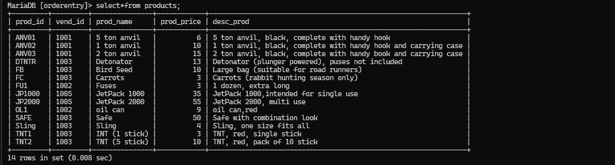

MariaDB [orderentry]> select*from products;

+---------+---------+---------------+------------+----------------------------------------------------------------+

| prod_id | vend_id | prod_name | prod_price | desc_prod |

+---------+---------+---------------+------------+----------------------------------------------------------------+

| ANV01 | 1001 | 5 ton anvil | 6 | 5 ton anvil, black, complete with handy hook |

| ANV02 | 1001 | 1 ton anvil | 10 | 1 ton anvil, black, complete with handy hook and carrying case |

| ANV03 | 1001 | 2 ton anvil | 15 | 2 ton anvil, black, complete with handy book and carrying case |

| DTNTR | 1003 | Detonator | 13 | Detonator (plunger powered), puses not included |

| FB | 1003 | Bird Seed | 10 | Large bag (suitable for road runners) |

| FC | 1003 | Carrots | 3 | Carrots (rabbit hunting season only) |

| FU1 | 1002 | Fuses | 3 | 1 dozen, extra long |

| JP1000 | 1005 | JetPack 1000 | 35 | JetPack 1000,intended for single use |

| JP2000 | 1005 | JetPack 2000 | 55 | JetPack 2000, multi use |

| OL1 | 1002 | oil can | 9 | oil can,red |

| SAFE | 1003 | Safe | 50 | Safe with combination look |

| Sling | 1003 | Sling | 4 | Sling, one size fits all |

| TNT1 | 1003 | INT (1 stick) | 3 | TNT, red, single stick |

| TNT2 | 1003 | TNT (5 stick) | 10 | TNT, red, pack of 10 stick |

+---------+---------+---------------+------------+----------------------------------------------------------------+

14 rows in set (0.008 sec)

* Table productnotes

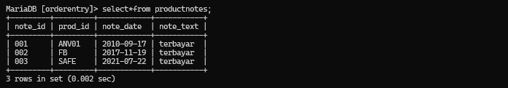

MariaDB [orderentry]> select*from productnotes;

+---------+---------+------------+-----------+

| note_id | prod_id | note_date | note_text |

+---------+---------+------------+-----------+

| 001 | ANV01 | 2010-09-17 | terbayar |

| 002 | FB | 2017-11-19 | terbayar |

| 003 | SAFE | 2021-07-22 | terbayar |

+---------+---------+------------+-----------+

3 rows in set (0.002 sec)

* Table vendors

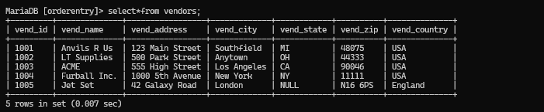

MariaDB [orderentry]> select*from vendors;

+---------+--------------+-----------------+-------------+------------+----------+--------------+

| vend_id | vend_name | vend_address | vend_city | vend_state | vend_zip | vend_country |

+---------+--------------+-----------------+-------------+------------+----------+--------------+

| 1001 | Anvils R Us | 123 Main Street | Southfield | MI | 48075 | USA |

| 1002 | LT Supplies | 500 Park Street | Anytown | OH | 44333 | USA |

| 1003 | ACME | 555 High Street | Los Angeles | CA | 90046 | USA |

| 1004 | Furball Inc. | 1000 5th Avenue | New York | NY | 11111 | USA |

| 1005 | Jet Set | 42 Galaxy Road | London | NULL | N16 6PS | England |

+---------+--------------+-----------------+-------------+------------+----------+--------------+

5 rows in set (0.007 sec)